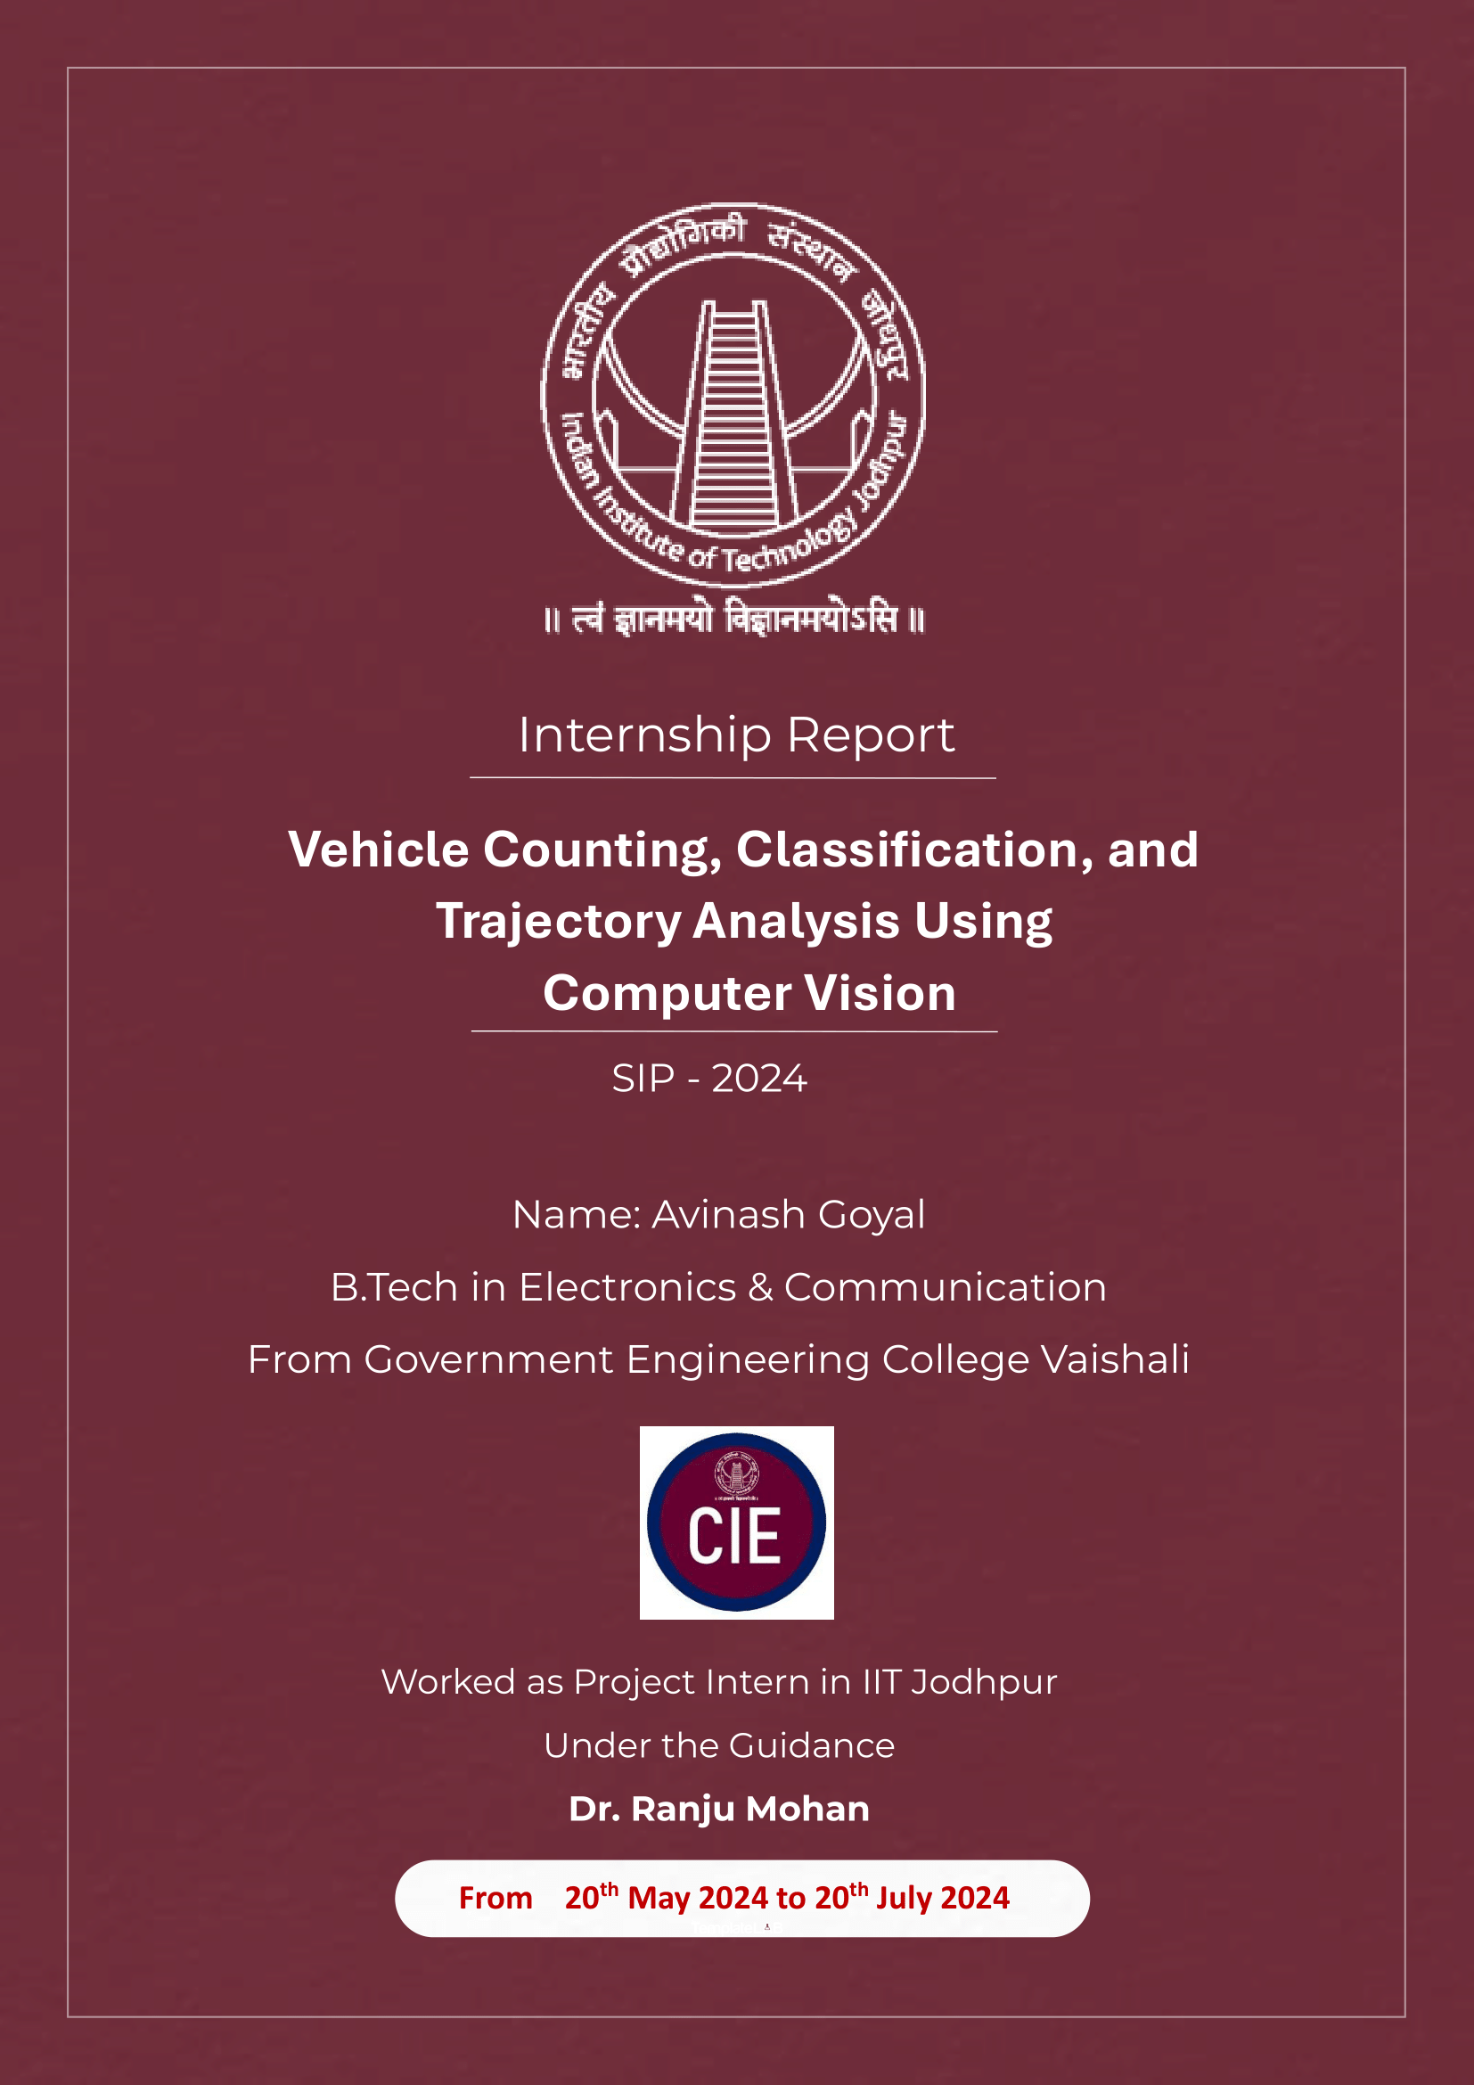

Contents

Internship Overview 1

Objectives of the Internship 1

Project Overview 1

Detailed Description of the Project 1

Tools Used 2

Methodologies 2

Perspective Transformation and Trajectory Prediction: 2

Vehicle Detection and Classification 3

Object Tracking and Speed Estimation: 4

Calculation of Traffic Safety Metrics: 4

Steps to Determine Potential Collision Point 5

1. Check Collision Course 5

2. Calculate Minimum Time to Collision T = - (r ⋅ v_relative) / (v_relative ⋅ v_relative) 5

3. Calculate Position at Closest Approach 5

4. Determine Potential Collision Point 6

**Steps After Determining the Collision Potential Point:** 7

Annotation and Output 9

Let's Dive into a Brief Overview of Our Application! 10

Future Work and Continuation: 15

Table of Figures

Figure 1 Real-Time Traffic Analysis at MGH Road, Jodhpur 2

Figure 2 Perception view of the footage 3

Figure 3 Detection of the Road-user 3

Figure 4 Bird-Eye-View of the footage 4

Figure 5 Classification of encounters based on spatial or temporal relation b/w the road user 4

Figure 6 Condition: user will collide 6

Figure 7 Condition : user will cross each othe path only 6

Figure 8 after running the application 9

## Internship Overview

In the summer of 2024, I had the opportunity to intern at the Indian Institute of Technology (IIT) Jodhpur, specifically in the Department of Civil and Infrastructure Engineering. The internship spanned from May 20th to July 20th, under the supervision of Dr. Ranju Mohan, where I actively contributed to a project focusing on traffic flow analysis and safety metrics at selected intersections in Jodhpur City.

## Objectives of the Internship

The primary objective of this internship was to apply computer vision techniques to analyze traffic dynamics, including vehicle counting, classification, and the assessment of various safety metrics such as Time to Collision (TTC), Deceleration to Safety Time (DST), and Post Encroachment Time (PET). This involved implementing algorithms to simulate traffic scenarios, predict vehicle trajectories, and enhance traffic management systems using geographic information systems (GIS).

## Project Overview

The project titled "Vehicle Counting, Classification, and Traffic Safety Metrics Analysis at Selected Intersections in Jodhpur City" aimed to develop models and algorithms for real-time analysis of traffic patterns. It focused on leveraging computer vision technologies to enhance traffic safety and efficiency at critical intersections. The project utilized Python programming along with libraries such as OpenCV, NumPy, YOLO from Ultralytics, and custom modules like Supervision for video processing and analysis.

## Detailed Description of the Project

**Objective:** The project aimed to analyze traffic flow and safety metrics using computer vision techniques. It involved:

* Implementing vehicle detection and classification using YOLO models for real-time video processing.
* Performing perspective transformations to achieve a bird's-eye view of traffic scenarios.
* Calculating traffic safety metrics such as Time to Collision (TTC), Deceleration to Safety Time (DST), Post Encroachment Time (PET), and Gap Time (GT) using Python and NumPy.
* Visualizing and annotating video frames with trajectory paths and safety annotations using OpenCV and Supervision.
* Integrating Kalman filtering for smoother object tracking and prediction.
* Exporting detailed analysis results to Excel for further assessment and reporting

## Tools Used

The project utilized the following tools and libraries:

* **Python**: Primary programming language for flexibility and integration.
* **OpenCV (cv2)**: Handling video frames, perspective transformations, and annotations.
* **NumPy**: Numerical operations and calculations for coordinates and velocities.
* **argparse**: Command-line argument parsing for flexible input and output specifications.
* **pandas**: Data management and exporting detailed results to Excel.
* **ultralytics YOLO**: Object detection and classification using YOLO models.
* **supervision (sv)**: Custom module for optimizing video annotations and managing video frames.
* **datetime**: Managing timestamps and time-related calculations within the video processing pipeline.

## Methodologies

The methodologies employed in the project encompassed a range of computer vision techniques and algorithms tailored for traffic analysis and safety assessment. These methodologies were crucial in achieving accurate vehicle detection, tracking, speed estimation, and calculating various traffic safety metrics such as Time to Collision (TTC), Deceleration to Safety Time (DST), Post Encroachment Time (PET), Gap Time (GT), Time to Accident (TA), and Conflicting Speed (CS).

Perspective Transformation and Trajectory Prediction: To obtain a bird's-eye view of traffic scenarios, perspective transformation techniques were applied. This involved defining source and target points within video frames to correct for perspective distortions, thereby facilitating accurate trajectory prediction and spatial analysis of vehicle movements within the intersection

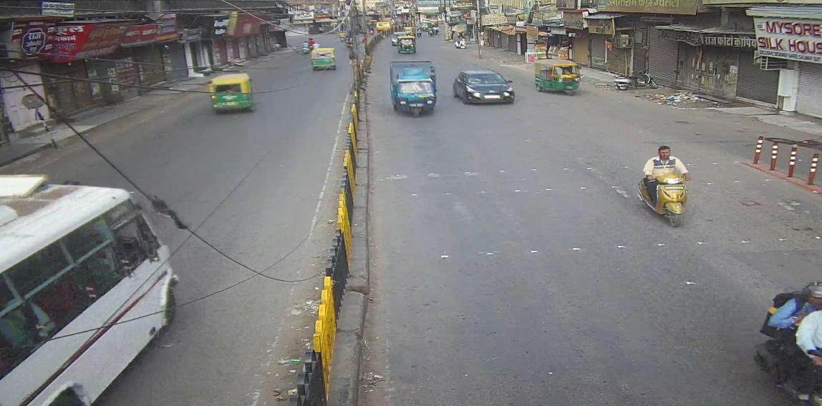

*Figure 1 Real-Time Traffic Analysis at MGH Road, Jodhpur*

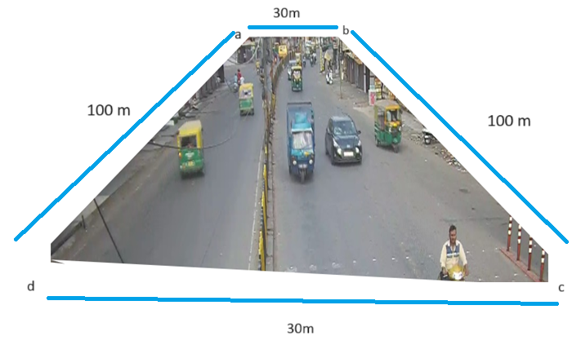

*Figure 2 Perception view of the footage*

**Source Points (in Pixels)**: These are specific coordinates within the video frame, typically identified by pixel positions (e.g., (100, 200), (300, 400)).

**Target Points (in Actual Length)**: These are the corresponding real-world coordinates where the source points should map after applying perspective transformation, measured in meters or another real-world unit (e.g., (5 meters, 10 meters)

Vehicle Detection and Classification

For this project, I utilized the YOLO (You Only Look Once) object detection model from Ultralytics, implemented through Python and OpenCV libraries. YOLO enabled real-time detection and classification of vehicles within video streams captured from intersections in Jodhpur City. This approach ensured robust performance in identifying various types of vehicles, including cars, trucks, and motorcycles, amidst varying lighting and environmental conditions.

To illustrate the effectiveness of this approach, I included example images from the video streams, demonstrating the accurate detection and classification of different vehicles under diverse conditions.

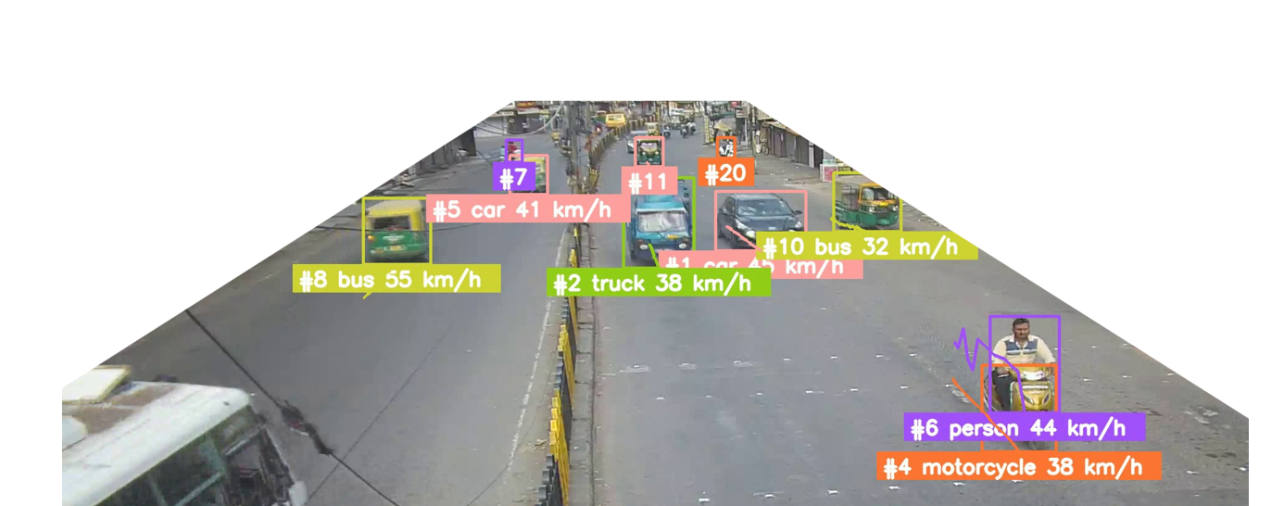

*Figure 3 Detection of the Road-user*

Object Tracking and Speed Estimation: For tracking vehicles across consecutive frames, I employed centroid tracking techniques. This method maintained the identity of vehicles across frames, facilitating smooth and accurate tracking. Speed estimation was achieved by calculating the distance traveled by vehicles between their previous and current positions and dividing by the time interval, providing real-time updates on vehicle velocities.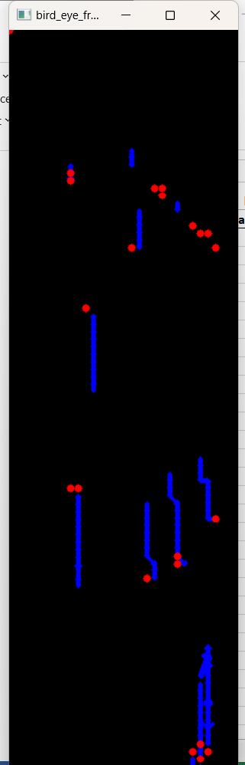

By using the bird's-eye view dimension, which represents real-world length and width, this approach ensured precise distance measurements and speed calculations, accounting for real-world dimensions and enhancing the accuracy of vehicle trajectory and velocity analysis.

Calculation of Traffic Safety Metrics: Once vehicles were detected, tracked, and their speeds estimated, several critical traffic safety metrics were computed:

"Before calculating the traffic safety metrics, it is essential to first identify the potential collision point between vehicles. This collision potential point serves as a reference for evaluating the following metrics: Time to Collision (TTC), Deceleration to Safety Time (DST), Post Encroachment Time (PET), Gap Time (GT), Time to Accident (TA), and Conflicting Speed (CS). Once the collision potential point is determined, these metrics can be accurately computed to assess traffic safety."

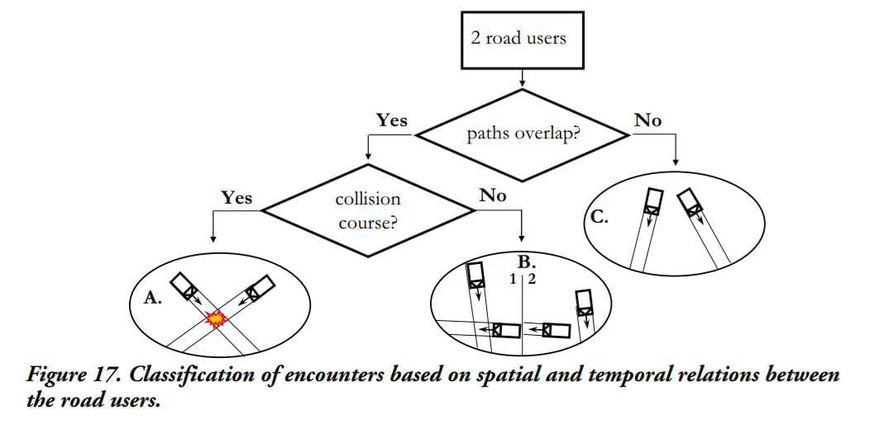

*Figure 5 Classification of encounters based on spatial or temporal relation b/w the road user*

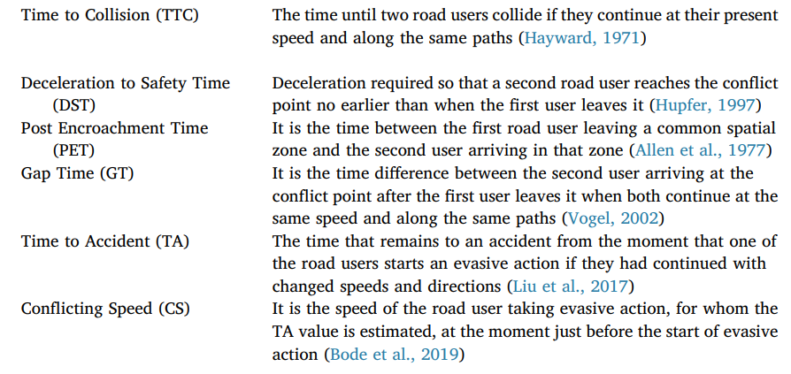

Steps to Determine Potential Collision Point

### 1. Check Collision Course

**Objective:** Determine if the objects are on a collision course.

**Method:**

* Calculate the relative position vector **r** and the relative velocity vector **vrelative.**
* Compute the dot product of **r** and **vrelative**.
* If the dot product is negative (**r . vrelative < 0**), then the objects are on a collision course.

### 2. Calculate Minimum Time to Collision T = - (r ⋅ v_relative) / (v_relative ⋅ v_relative)

**Objective:** Find the time **T** when the objects are closest to each other.

**Method:**

* Use the formula:

$T=-\frac{r⋅v_{relative}}{{(v}_{relative}).(v_{relative})}$

* If T < 0 or the relative velocity is zero, return float('inf') indicating no collision.

### 3. Calculate Position at Closest Approach

**Objective:** Determine the positions of the objects at time T.

**Method:**

* Compute the positions of both objects at time T:

$position\left(t\right)=p+v⋅t​$

pos1_at_min_T = position1 + velocity1 * T

pos2_at_min_T = position2 + velocity2 * T

### 4. Determine Potential Collision Point

**Objective:** Check if the objects are close enough at time T to be considered a collision.

**Method:**

* Compare the positions pos1_at_min_T(**p1**) and pos2_at_min_T(**p2**).
* If the positions are same or very close, the potential collision point is at pos1.

| p1≅p2.    *Figure 6 Condition: user will collide*  Collision b/t them.   Collision Potential Point:  either **p1 = p2** | p1≠p2    *Figure 7 Condition : user will cross each othe path only*  If not close(p1≠p2), evaluate additional criteria to determine if the trajectory of one object intersects with the other’s.  Collision Potential Point: either **p1** or **p2** |
| --- | --- |

If p1≠p2, then further calculate

$min_T1=-\frac{r1⋅{v1}_{relative}}{{(v1}_{relative}).({v1}_{relative})}$

$min_T2=-\frac{r2⋅{v2}_{relative}}{{(v2}_{relative}).({v2}_{relative})}$

Where, $r1=p1-p2$

$r1=p1-p2$

${v1}_{relative}=v1-(0,0)$

${v2}_{relative}=v2-(0,0)$

| **Condition** | min_T1=∞ and min_T2=∞: | min_T1=∞ and min_T2>0: | **Else** |
| --- | --- | --- | --- |
| **Potential Collision Point** | None | pos1_at_min_T  (p1) | pos2_at_min_T  (p2) |

**Steps After Determining the Collision Potential Point:**

**Compute Safety Metrics:** Calculate traffic safety metrics such as Time to Collision (TTC), Deceleration to Safety Time (DST), Post Encroachment Time (PET), Gap Time (GT), Time to Accident (TA), and Conflicting Speed (CS).

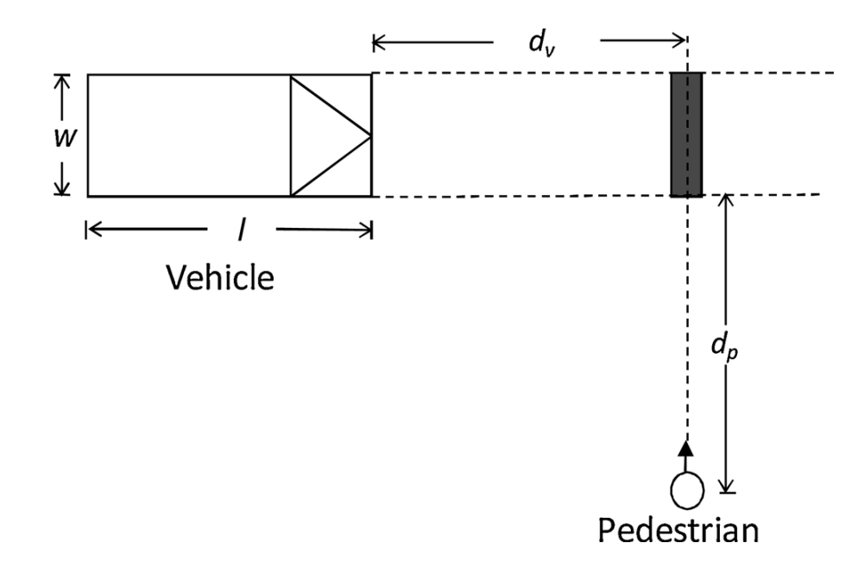

* **Time to Collision (TTC)**: The time until two road users collide if they continue at their present speed and along the same paths.

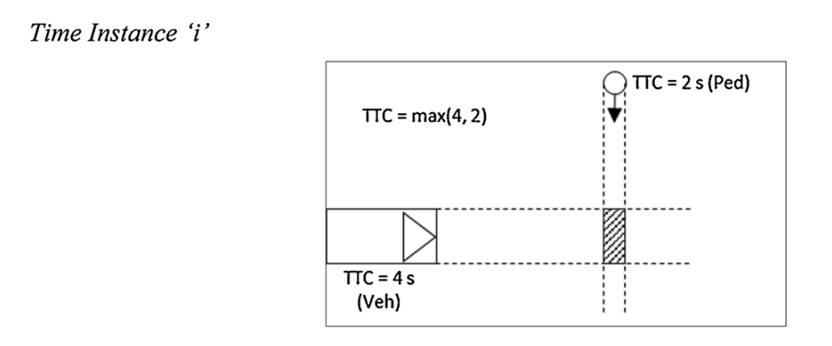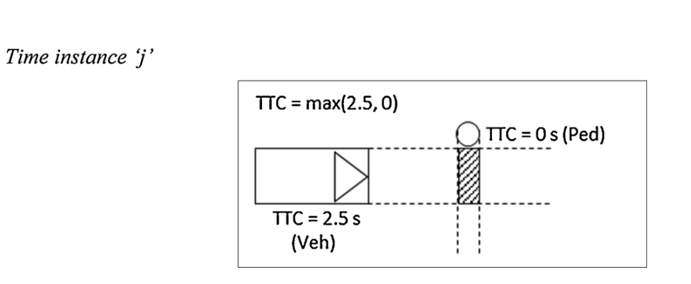

$TTC=max(\frac{d_{a}}{v_{a}},\frac{d_{b}}{v_{b}})$

Where, $\frac{d_{a}}{v_{a}}$ is the time for Object 1.

$\frac{d_{b}}{v_{b}}$ ​​ is the time for Object 2.

* **Gap Time (GT)**: Measured as the time interval between successive vehicles passing through a specific point within the intersection, crucial for assessing traffic flow efficiency and safety.

Mathematically, GT is calculated as follows:

$GT=\left|\frac{d_{a}}{v_{a}}-\frac{d_{b}}{v_{b}}\right|$

**(Note:** Individual collision times may be adjusted to account for the length of the object. The length of the object affects the distance calculation, thereby impacting the collision time. This adjustment is made by adding the object's length to the distance travelled.)

The minimum Gap Time (GTmin) is extracted from a set of GT values to indicate the maximum severity of the interaction. This metric is crucial in understanding and improving traffic safety by identifying critical moments when vehicles or pedestrians are at risk of collision.

* **Deceleration to Safety Time (DST)**: Estimated by analyzing the rate of deceleration necessary for vehicles to safely avoid collision within the current traffic flow.
* **Post Encroachment Time (PET)**: Defined as the duration after a vehicle passes through an intersection during which it remains susceptible to potential conflicts with other vehicles.
* **Time to Accident (TA)**: Similar to TTC but includes factors such as vehicle maneuvers and traffic flow dynamics to predict potential accidents.
* **Conflicting Speed (CS)**: Determined by comparing the speeds of vehicles approaching an intersection, highlighting scenarios where speed differentials may lead to traffic conflicts.

These methodologies were integrated into a cohesive pipeline using Python scripts, leveraging libraries such as NumPy for numerical computations and pandas for organizing and exporting analysis results into structured Excel spreadsheets. The combination of these techniques not only facilitated comprehensive traffic analysis but also contributed to enhancing traffic management strategies and improving safety measures at critical intersections in Jodhpur City.

Annotation and Output

In the final step, I annotated the video frames with detection and tracking information and saved the results to an output video file. The process involved the following steps:

**1. Annotation of Detections:**

* **Bounding Boxes:** The BoundingBoxAnnotator was used to draw bounding boxes around detected vehicles in each frame.
* **Labels:** The LabelAnnotator added labels showing the tracker ID and vehicle type, along with the calculated speed.
* **Trajectories:** The TraceAnnotator visualized the movement trajectories of detected vehicles.

**2. Bird's-Eye View Visualization:**

* **Perspective Transformation:** The ViewTransformer was used to create a bird's-eye view of the traffic scenario by transforming the perspective of the video frame.
* **Trajectories:** Vehicle trajectories were plotted on the bird's-eye view using arrows.
* **Kalman Filter Predictions:** The KalmanFilter was used to predict and visualize the future positions of vehicles, represented as circles in the bird's-eye view.

**3. Output Video and Excel Export:**

* **Video Output:** The annotated frames were compiled into an output video using VideoSink. This video includes all visual annotations and labels.
* **Excel Export:** A DataFrame containing metrics and annotations was saved to an Excel file, including details such as frame number, time, tracker ID, vehicle type, position, speed, and calculated safety metrics.

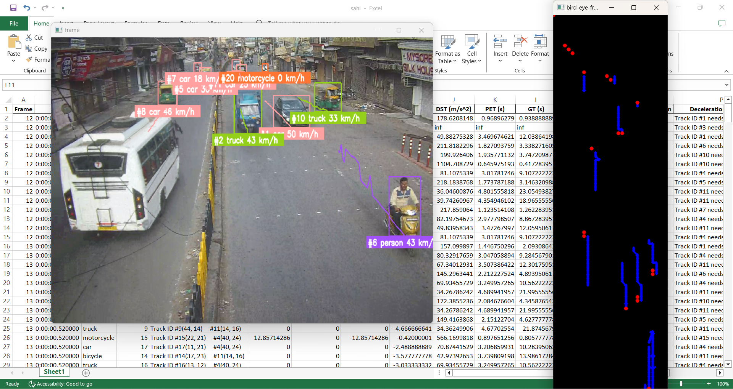

*Figure 8 after running the application*

By applying these annotations, the resulting video provides a comprehensive view of vehicle movements, interactions, and safety metrics, enhancing the analysis and understanding of traffic scenarios.

# Let's Dive into a Brief Overview of Our Application!

Welcome to our cutting-edge Vehicle Speed Estimation and Traffic Safety Metrics Application! 🌟

**What is This Application About?**

Our application is designed to transform video footage into actionable traffic insights. By utilizing state-of-the-art computer vision and object detection technology, it provides real-time analysis and safety metrics for vehicle tracking.

**Here’s How It Works:**

1. **Easy Setup:**

**Open the Application:** Start by launching the application, and a user-friendly window will appear.

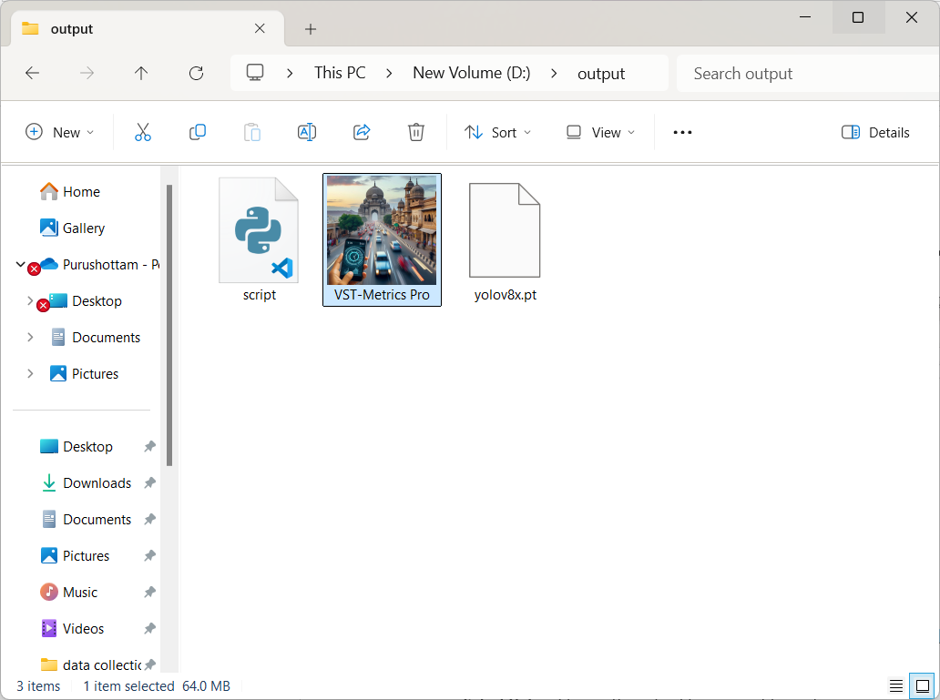

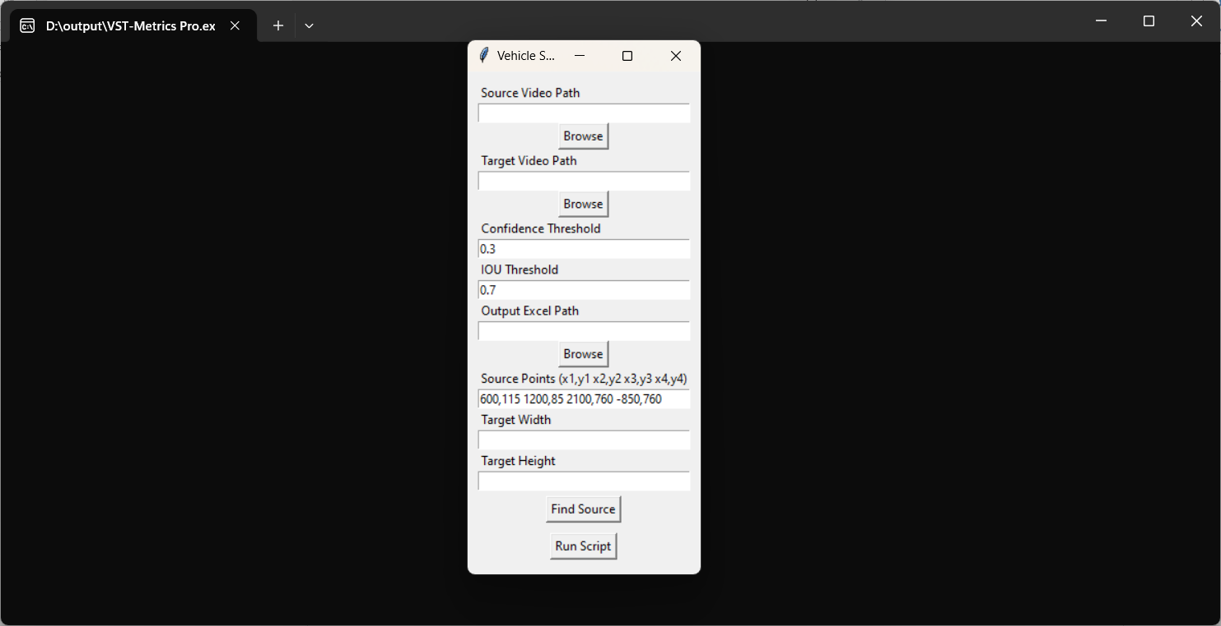

**2. Configure Your Inputs:**

* **Select Video:** Choose the video file you want to analyze.

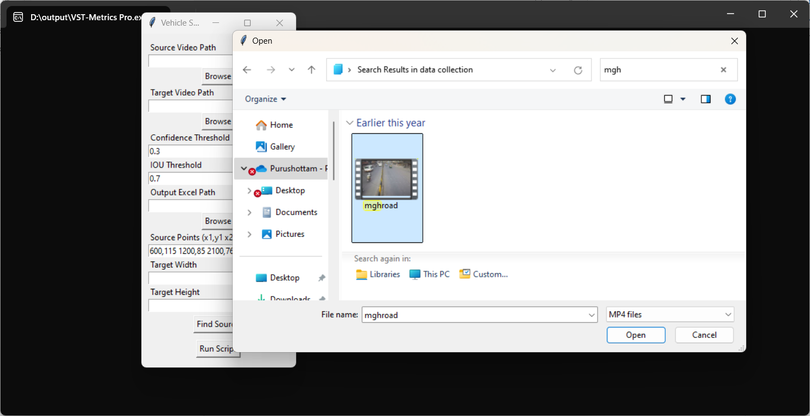

* **Set Output Paths:** Define where the processed video and analysis results should be saved.

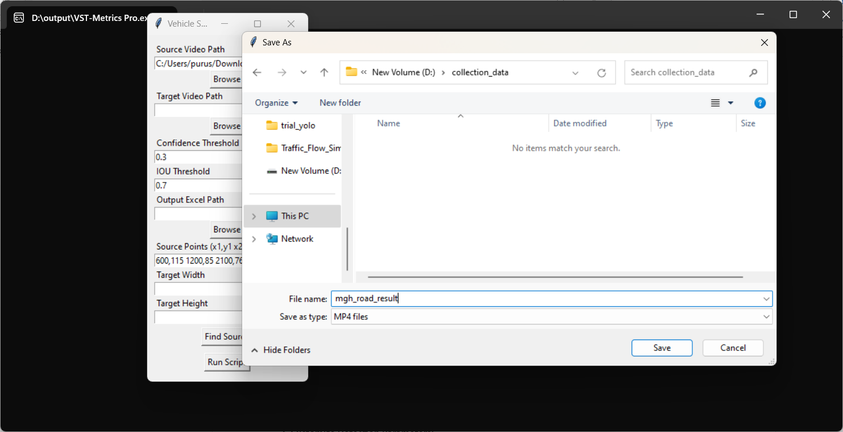

**3. Customize Detection Parameters:**

* **Confidence & IOU Thresholds:** Adjust these settings to fine-tune object detection accuracy based on factors like lighting and environmental conditions. The Confidence Threshold helps filter out less certain detections, while the IOU (Intersection Over Union) Threshold refines how overlapping detections are handled. Adjusting these parameters ensures better accuracy and reliability of object detection in varying conditions.

4. **Output Excel Path:** Specify the location where the application will save the detailed analysis results in an Excel file. This file includes:

* **Vehicle Metrics:** Speed, trajectory, and other vehicle-related data.
* **Safety Metrics:** Gap Time (GT), Time to Collision (TTC), and other traffic safety metrics.
* **Visual Data:** Annotations and trajectory paths, if included, for comprehensive review.

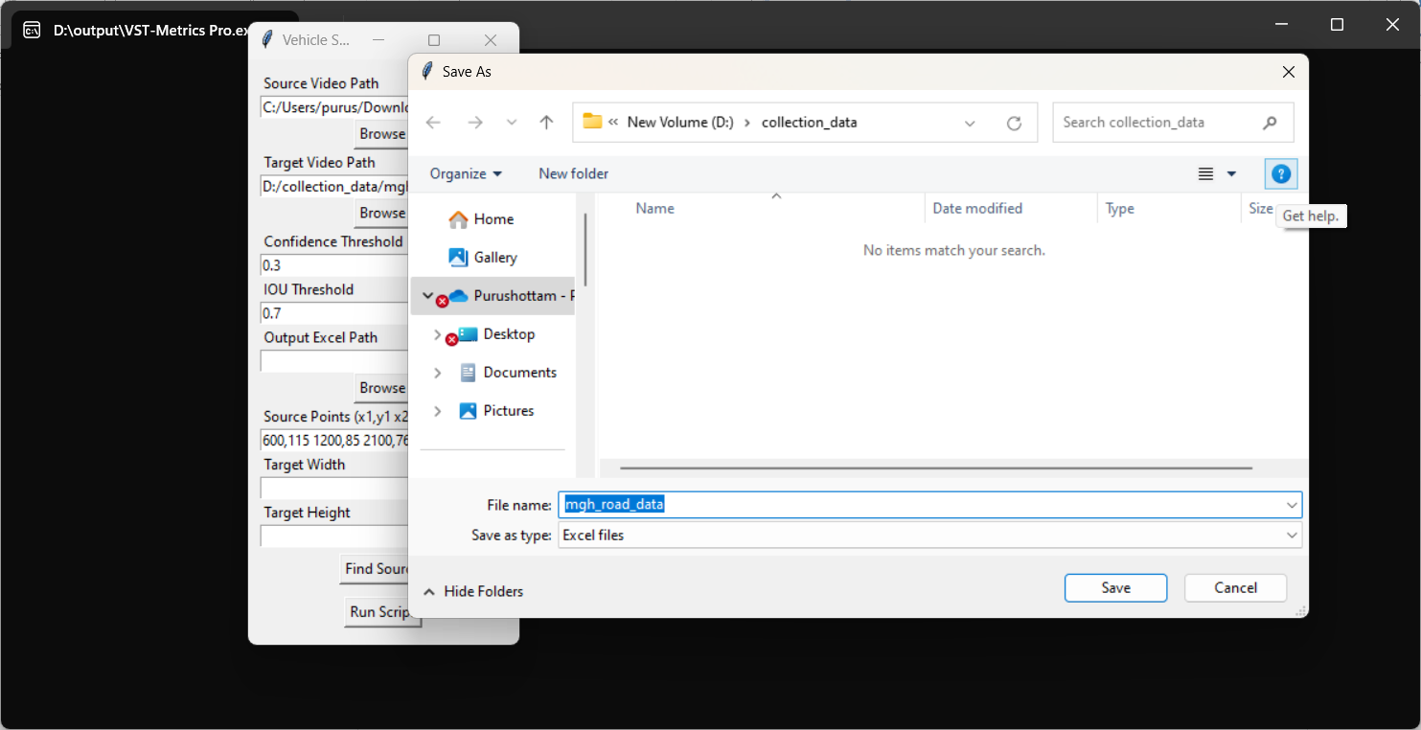

**4. Define Perspective Transformation:**

* **Source Points & Target Dimensions:** Input these parameters to convert your video to a bird’s-eye view. This transformation simplifies the analysis by providing a top-down perspective of the traffic scenario, allowing for more accurate measurement and tracking of vehicles or pedestrian movements. 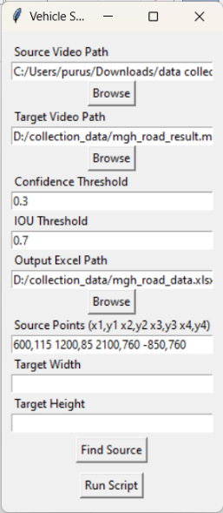

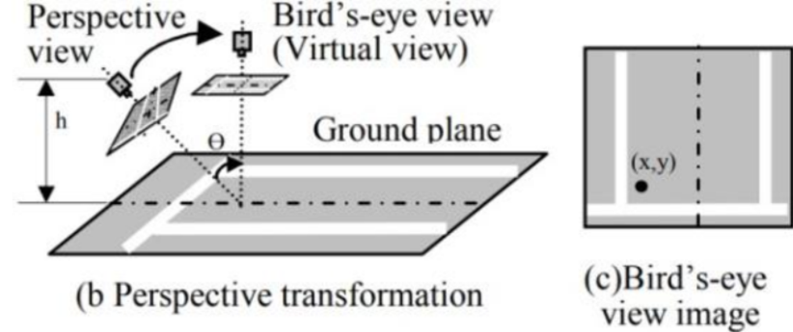

* I’m here adding a feature to determine the source points as well. Here’s how it works:

1. **Click "Find Source " Button:** Initiate this feature by clicking the "Find Source Points" button.
2. **Choose Video:** Select the video you want to analyze. 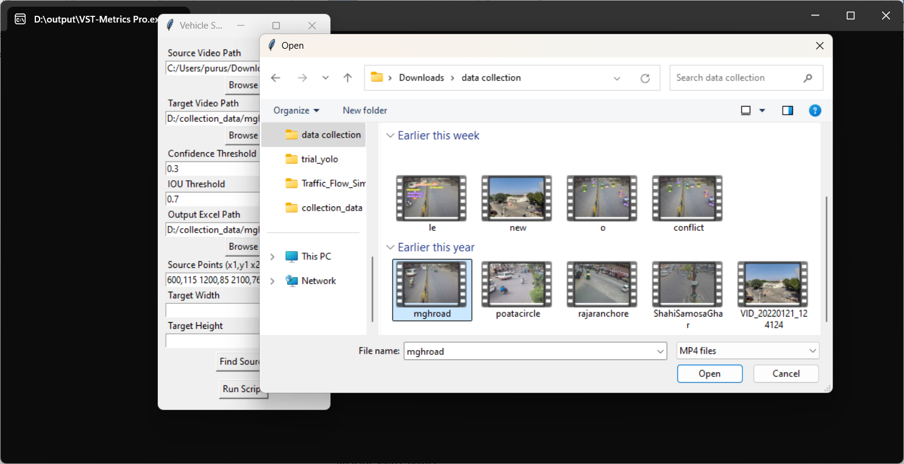
3. **Click Four Points:** On the output canvas, click on four points to define the area you want to analyze.

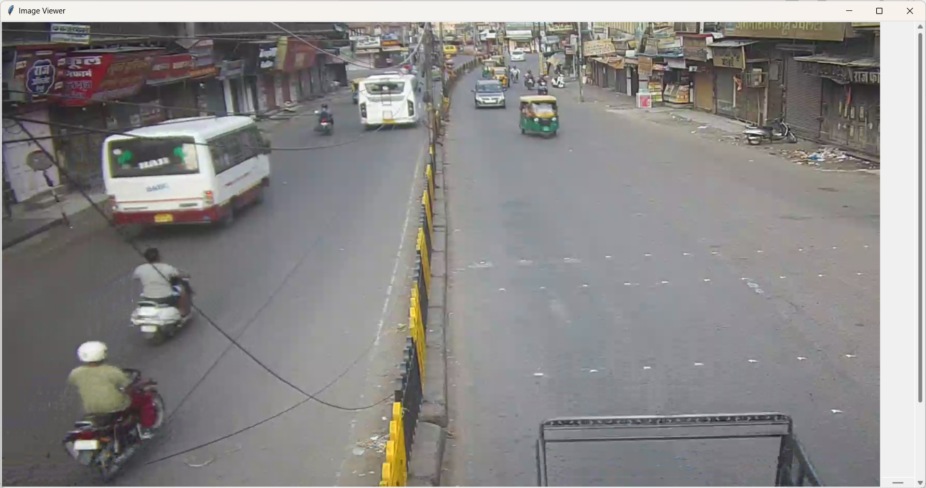

1. **View and Copy Source Points:** After clicking the four points, the source points will be displayed in the command prompt window. Copy these points and paste them into the text area for source points.

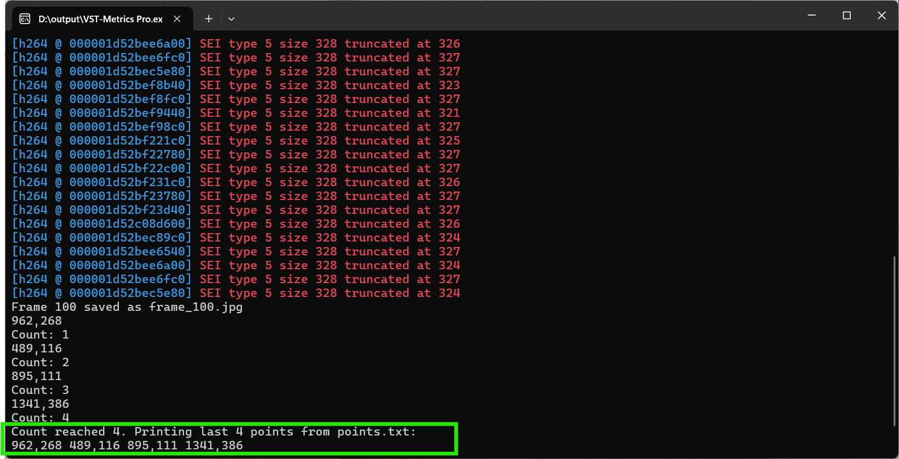

**Tip**: For more accurate values, you may prefer to use GIMP software to define the source points. This tool can help you achieve higher precision in your perspective transformation.

**5. Run and Analyze:**

* **Start Processing:** Click “Run” to begin. The application will handle the rest—detecting vehicles, calculating metrics, and annotating your video.

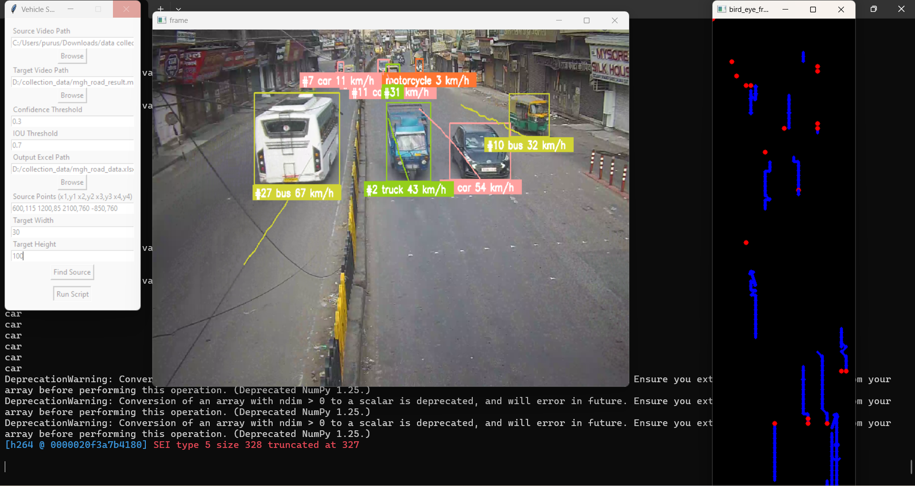

**6. Review Results:**

* **Annotated Video:** Watch the video with real-time annotations and trajectory paths.
* **Excel Report:** Check the detailed metrics in the output Excel file.

**7. Exit Gracefully:**

* **Close the Application:** The application will automatically close once processing is complete. If you wish to close it manually, click on the output frame and press the "q" button on your keyboard.

**Why Use This Application?**

* **Real-time Analysis:** Provides instant feedback and metrics for traffic safety.
* **Customizable Parameters:** Adjust detection settings to fit your specific needs.
* **Detailed Reporting:** Generates comprehensive reports to help with traffic management and safety improvements.

**Application Access and Processed Data:**

For further exploration and use of the Vehicle Speed Estimation and Traffic Safety Metrics Application, please visit the following link:

VST-Metrics Pro 🡪 [download link](https://drive.google.com/drive/folders/1mjBtJ93uugmWMlRtuKcogYqrTmUIGdZ5?usp=sharing)  
  
 Processed Data 🡪 [Link](https://drive.google.com/drive/folders/1EXWWNUs_pBcaLomqDWPZiTwpmXMhSls-?usp=sharing)

# Future Work and Continuation:

While this project has made significant strides in enhancing traffic safety and efficiency at critical intersections, there is still room for further enhancement. To achieve more accurate results, we plan to refine the Excel sheet for better accuracy in vehicle counting and other metrics. Future work will focus on improving accuracy, scalability, and real-time processing capabilities. This project is ongoing and will continue to evolve, incorporating advanced algorithms and broader applicability to various traffic scenarios.

To be continued...!